**SULIMO JOINT EXAMINATION**

**MARKING SCHEME**

**GEOGRAPHY**

**PAPER 1**

**TIME 2 HRS 45 MIN.**

**SECTION A: (25 MARKS) ANSWER ALL QUESTIONS .**

1. (a). What is Solar System. (2mks)

**The solar system is made up of the sun , the planets and other heavenly bodies like comets/meteors that revolve around the sun.**

(b) State **three** characteristics of the core. (3mks)

* **It is the innermost/central layer of the earth.**
* **It has a radius of about 3475km.**
* **It consists of rocks rich in iron and nickel**
* **It has a high pressure**
* **It has high temperatures of about 55000 c.**
* **It is divided into two layers namely outer core and inner core.**

2. (a) Differentiate between a rock and a mineral. (2mks)

**A mineral is an inorganic substance occurring naturally beneath/at the earth’s surface while a rock is a naturally occurring aggregates of mineral particles forming part of the earth’s crust.**

(b) Describe the formation of mechanically sedimentary rocks. (3mks)

* **Sediments used to form the rocks are derived from weathering of existing rocks.**
* **The weathered materials are transported by wind/water/moving ice**
* **The weathered materials are deposited in layers on land or in sea.**
* **They are then compacted and cemented into mechanically formed sedimentary rocks e.g sandstone, mudstone, shale, claystone,breccia, grit e.t.c.**

3. Describe how Gravitative pressure causes earth movements. (5mks)

**Large quantities of magma that escape from the upper mantle to the surface leave behind large voids /hollows.**

**Force of gravity then acts on the crustal rocks overlying the voids, exerting pressure on the rocks.**

**Eventually the overlying crustal rocks crumble inwards to fill up the voids/hollows below , this leads to vertical displacement of rocks.**

4. ( a) What is River rejuvenation. (2mks)

**It is the renewal of the erosive power of a river.**

(b) Identify three ways in which a river transports its load. (3mks)

* **Solution**
* **Suspension**
* **Traction**
* **Saltation/hydraulic lift.**

5. (a) Name two processes of wind erosion the desert areas. (2mks)

* **Abrasion**
* **Deflation**
* **Attrition**

(b) State three reasons why wind erosion is effective in deserts. (3mks)

* **There are a lot of loose/unconsolidated dry materials which are easily eroded.**
* **Hot deserts experience strong , tropical storms which facilitate wind erosion**
* **Hot desert surfaces are bare/ have scanty vegetation cover leaving most of the surface exposed to wind erosion.**

**SECTION B. ANSWER QUESTION 6 AND ANY OTHER TWO.**

6. Study the map

1. (i) Identify the index to adjoining sheet to the south East of mumias. (1mk)

(ii) Calculate the area of Nyanza province in the area covered by the map. (2mks)

(iii) Give the longitudinal extent of the area covered by the map. (2mks)

1. Calculate the direction of Indagalasia school from air photo principal point 54 to the south of Buduma. (2mks)
2. (i) Describe the drainage of the area covered by the map. (5mks)

(ii) Explain three factors that favour crop farming in the area covered by the map.(6mks)

1. Draw a rectangle measuring 14cm by 8 cm to represent the area to east of easting 60 and north of northing 40. (1mk)

On the rectangle , mark and label the following.

1. All weather loose surface. (1mk)
2. River Nzoia (1mk)
3. Mwira School. (1mk)
4. Citing Evidence from the map Identify three social functions of Butula Muandas area (3mks)

7. a. (i) What is a climax vegetation? (2 mks)

**Refers to the plant cover that has established itself without interference from man in relation to the physical environment of climate, relief and soils.**

(ii) State four characteristics of the Mediterranean type of vegetation. (4 mks)

* **Some plants have small/thick-skinned/leathery /spinny leaves.**
* **Some plants have long roots.**
* **Grasses dry off during summers and germinates during winter.**
* **Some trees are deciduous**
* **some plants have fleshy leaves.**
* **Some plants have thick barks.**
* **Vegetation is adapted to long hot and dry summers.**
* **Some plants have large fleshy bulbous roots.**
* **Some plants are evergreen.**
* **Some plants have long tap roots.**
* **Woody scrubs are common in very dry areas.**
* **Tree species are olive, sweet chestnut, beech, cedar, cypress, eucalyptus e.t.c.**
* **Many plants are sweet smelling(aromatic) e.g rosemary lavender, oleander, broom and myrtle.**

b. Explain three factors which influence the distribution of vegetation in Kenya. (6 mks)

**Altitude/Relief**

* **High altitude areas have low temperatures which encourage scanty /no vegetation**
* **Low altitude have moderate temperatures which encourage dense vegetation.**
* **There is no vegetation on mountain tops due to very low temperature which inhibit plant growth.**
* **Gently sloping areas are well drained hence encouraging dense vegetation growth.**
* **Steep slopes experience excessive drainage that discourage plant growth hence scanty or no vegetation.**
* **Flat areas tend to be water logged hence covered by swamp plant species.**

**Aspect**

* **Windward slope of mountains/hills support growth of a wide variety /dense vegetation.**
* **The leeward side supports scanty vegetation.**
* **The south facing slopes of temperate latitude areas of the Nothern hemisphere tend to favour luxuriant growth of forest, while the North facing slopes encourage the growth of grass. And vice versa. On the southern hemisphere.**

**Climate**

* **Rainfall-** Areas receiving high rainfall encourage growth of many varieties of tree species/ luxuriant vegetation/ forest.
* Areas receiving low rainfall have few species/ scanty vegetation.
* Areas of low rainfall have stunted vegetation.

**Temperature**

* Areas experiencing moderate temperatures have a variety of tree species.
* Extreme temperatures/ very low/ very high temperatures leads to scanty vegetation in an area

**Wind**

* Very strong winds lead to breakage of tree branches or lead to physical damage inhibiting plant growth.
* Winds helps in dispersing seeds and pollination thus enhancing the distribution of vegetation on the Earth’s surface.
* Moist winds cause increased precipitation in areas they blow over hence large number of plants.
* Hot dry winds cause dry conditions in areas they blow over hence scanty vegetation.

**Edaphic/ Pedological/ soil factors**

* Deep, well drained soils support growth of dense vegetation.
* Shallow/ thin soils support scanty vegetation.
* Medium textured soils are well drained thus support a variety of plants/ dense vegetation.
* Coarse/ fine textured soils are poorly drained leading to scanty/ no vegetation.
* Deep soils enable the penetration of long roots thereby supporting trees/ forest.
* Thin soils support vegetation with shallow roots thereby supporting grass vegetation.

**Anthropogenic/ Biotic/ Biological Factors.**

**Competition**

* Plants compete with one another for water, light and space.
* As vegetation density increases, competition also increase and the dominant species kill the weaker ones.

**Effects of living organisms.**

* Bacteria, earthworms and burrowing animals improve soil fertility resulting into more vegetation growth.
* Insect and birds pollinate plants enhancing their propagation.
* Some insects like termites and aphids may attack some trees like pine destroying them reducing vegetation cover in an area.
* Large herds of wild animals can destroy vegetation through over grazing and can turn grasslands into deserts.
* Animals, birds and some insects aid in seed dispersal and this facilitates the thriving of certain plants in certain regions.

**The effects of human beings.**

* Afforestation and reafforestation creates forest in an area.
* Deforestation leads to no vegetation in an area.
* Pollution from industries limits growth of plants.
* Forest fires destroy plant species reducing vegetation cover.

c. Give Reasons why Tundra region has scanty vegetation. (3 marks)

* **very low temperatures hinders vegetation growth.**
* **There is bare rock/no soil to support vegetation.**
* **There is permanent cover of snow and snow/permafrost most of the year limiting vegetation growth.**

(c) Write the names of the grasslands found in the following areas (3 marks)

(i) East Africa- **Tropical/ savanna grasslands**

(ii) Canada. **The prairies**

(iii) Argentina**. The pampas**

(d) You are required to carry out a field study of the vegetation within the local environment:

(i) Apart from identifying the different types of plants, state three other activities you will

carry out during the field study. (3 marks)

* **Observing the trees**
* **Taking to photographs of the trees**
* **Interviewing the local people**
* **Administering questionnaires**
* **Writing notes**
* **Drawing sketches**
* **Collecting and labelling samples**

(ii) Give two reasons why it would be necessary to sample out part of the area covered

by the vegetation for the study (2 marks)

* **To do a detailed study.**
* **To reduce cost of the study.**
* **To save on time.**
* **Area too large to cover as a whole in a day.**
* **Less tiring to study a small area.**
* **Some parts may not be accessible as there are no roads.**
* **Helps reduce bias.**
* **Helps focus on relevant areas for the study.**
* **Suitable as vegetation grows randomly.**

(iii) List two methods they may have used to collect data (2marks)

* **Observing**
* **Interviewing**
* **Administering questionnaires**
* **Sampling**
* **Note making**
* **Photographing/video recording/filming**
* **Counting/Census taking**
* **Reading secondary sources/content analysis**
* **Taking measurements**
* **Reading instruments.**

8 (a) (i) What is mass wasting . (2mks)

* **Mass wasting is the down slope movement of weathered materials under the influence of gravity.**

(ii) Explain three factors influencing mass wasting. (6mks)

**The angle of the slope**

* Movement of weathered material is faster on steep slopes than on gentle slopes due to the influence of gravity.

**Climate of an area-**

* Weathered material in areas receiving heavy rainfall move faster since wet materials have less cohesion.
* Alternate freezing and thawing encourages movement of weathered materials down the slope.

**Nature of the rock-**

* Massive rocks overlying weak rocks move/ slide faster along the slope.
* Large rocks are likely to be overcome by gravity more easily than finely weathered materials.
* Steeply dipping rocks will easily experience movement.
* When materials contain a lot of water they are lubricated/ saturated and become susceptible to rapid movement.

**Vegetation cover in an area**

* Surfaces with vegetation experience less mass wasting because it binds weathered material together.
* Bare surfaces are more likely to experience mass wasting because there is no vegetation to bind the materials together.

**Earth movements**

* Volcanic eruptions/earthquakes cause tremors which may trigger displacement of materials/wide spread mass wasting.

**Human activities**

* Ploughing/ clearing of vegetation/ mining/ quarrying affect the stability/ loosen the surface materials causing their movement downslope.
* External forces from moving vehicles/ earth tremors from explosives shake the ground causing some materials to move downslope.

b.(i) Identify three processes of rapid mass wasting. (3mks)

* **Earthflows**
* **Mudflows**
* **Landslides/landslips**
* **Avalanche**

(ii) Describe the process of solifluction. (5mks)

* **It is a slow movement of saturated soil, gravel and weathered rock materials down a moderate gentle slope under the influence of gravity.**
* **In moderately/gently sloping areas during winter water in the soil freezes thus freezing the soil.**
* **When the weather becomes warm, the top soil thaws.**
* **Overtime the top soil becomes saturated with water while the sub-soil remains frozen (permafrost).**
* **The saturated mass of top soil creeps over the frozen ground (permafrost). This process is known as solifluction.**

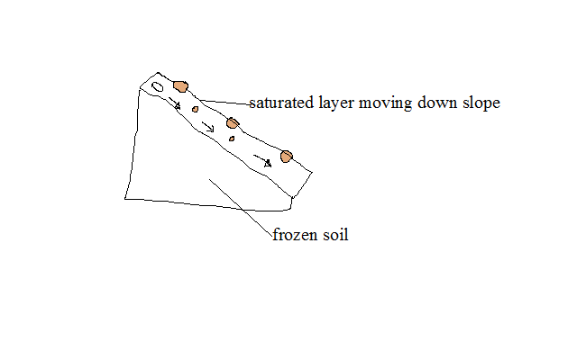**not a must to draw.**

(c) State effects of soil creep to the environment. (4mks)

* **Areas affected by mass wasting have become centres of research.**
* **Areas prone to mass wasting have encouraged environmental conservation strategies like afforestation/gabion building/agroforestry/reafforestation**
* **Materials deposited at the base of slopes form deep, well drained soils supporting crop growing-**
* **Soil creep may destroy walls built across the slope when creeping soil exerts pressure on them.**
* **It leads to destruction of vegetation.**
* **It leads to blockage of rivers/disruption of flow of rivers reducing volume of water downstream.**
* **It leads to exposure of land to agents of soil erosion.**

(d) Students of Sunshine conducted a field study in an area affected mass wasting

(i) Identify three methods that might have been used to control soil erosion (3mks)

* **Mulching**
* **Planting cover crop**
* **Contour ploughing.**
* **Afforestation and reafforestation**
* **Regulation of livestock**
* **Terracing**
* **Building of gabions.**

(ii) State two follow up activities that they would have engaged in after the study. (2mks

* **Asking/answering question.**
* **Assessing the information collected against the hypothesis.**
* **Consulting geography teachers.**
* **Data analysis/Data presentation.**
* **Discussion about findings/discussing the findings.**
* **Displaying of photographs taken/items collected.**
* **Drawing conclusions.**
* **Drawing diagrams**
* **Reading more on the topic.**
* **Report writing.**
* **Sketching the features.**

9. (a) )i) Differentiate between Karst Scenery and Karst Region. (2mks)

* **Karst scenery** is a limestone/ dolomite/ chalk area/ region where water action has created unique rugged features on the surface and underground while Karst region is an area with chalk or dolomite.

(ii) Identify two sources of underground water. (2mks)

* **Precipitation/ Rainwater.**
* **Melting glacier/ Melt water.**
* **Water bodies like sea/ ocean/ lake water.**
* **Magmatic water- water tapped in the rocks underground during volcanicity (plutonic water).**

b) (i)Explain how the following factors influence the occurrence of underground water.

-Nature of the rock

**Rocks with large spaces have high ability of allowing water to percolate through them thus availing underground water.**

**Permeable rocks allow easy water infiltration than impermeable rocks thus availing underground water.**

- Gradient of the land (2mks)

* **The more gentle a slope is the greater the percolation of water into the ground than steep slope which allow fast surface runoff.**

(ii) State four conditions that are necessary for the formation of an artesian well

(4mks)

**The aquifer must be exposed in an area of sufficient precipitation/ water source** to provide more water into the well preventing it from drying.

**The aquifer must be sandwiched/ lie between two impermeable rock layers** so that it can retain *water.*

**The mouth of the well must be lower than the intake area** to ensure water has sufficient pressure to flow out naturally.

**The rock structure must form a shallow syncline** such that the mouth of the well is at a lower level to ensure sufficient pressure to naturally force out water.

**The margins of the aquifer must be exposed** to allow water to infiltrate.

**There must be a partial or total blockage of exit for the water** to be replaced under pressure.

**The aquifer must be of the same permeable materials** so as to retain water.

(c) Explain three conditions that are necessary for development of Karst Scenery

(6mks)

* **The rainfall should be moderate to high/ humid conditions.**
* **The temperatures should be high/ hot conditions.**
* **Presence of hard/ well jointed rocks.**
* **The water-table should be deep below the surface.**
* **The area should have thick limestone/ chalk/ dolomite on the surface and beneath.**

(ii) Give two reasons why there are few settlements in karst region

* **The landscape is rocky/ rugged thus discourages settlement.**
* **The region experiences inadequate water supply both on the surface and underground discouraging settlement.**
* **The surface in most places has thin soils which discourages crop farming.**
* **There is scarcity of vegetation in most places limiting rearing of livestock.**
* **The landscape is rugged hindering development of transport network.**

(2mks)

(d) Students from Light Academy carried out a field study in a karst landscape.

(i) State two methods they would have used to record data (2 mks)

* **Note taking.**
* **Photographing.**
* **Field sketching/drawing diagrams.**
* **Filling in questionnaire**
* **Tape recording.**
* **Video recording/filming.**
* **Labelling of samples.**

(ii) State three importance of studying a karst landscape through field work. (3mks)

* **It allows for easy recall.**
* **It enables one to get first-hand information.**
* **It helps learners understand better theoretical concepts taught in class / teaching becomes easier.**
* **It helps students develop skills of data collection.**
* **It enables collection of samples for future reference.**
* **It makes learning interesting.**
* **It makes learning real/meaningful.**

10. (a) (i) Distinguish between an Ocean and a sea. (2mks)

* **An ocean is a large/extensive body of saline water occupying a basin between continents while A sea is a large body of saline water along the continental margins.**

(ii) Identify three factors that influence the level of salinity in Ocean water. (3mks)

* **Latitude- ocean salinity is higher near the tropics due to high temperature causing evaporation. It decreases towards the equator because of heavy rainfall and less evaporation due to high humidity and more cloud cover.**
* **Depth- The surface water is generally more saline than the bottom water.**
* **The position of the inland water- Seas located in regions of high temperatures, with little rainfall and few rivers emptying into them tend to have high salinity and vice versa.**

(b) Explain three causes of horizontal movement of ocean water. (6mks)

**Winds blowing over the ocean** causing a mass of surface ocean water to move in its direction forming drift currents.

**Rotation of the earth** by causing deflection of ocean currents.

**Shape of the coastal land mass** by influencing current direction and causing it to flow following the coastal outline.

**Differences in ocean water temperature** bycausing cold polar water which is dense due to low temp moves towards the equator passing on the ocean floor and warm water of the tropics to move towards the poles passing on the surface.

**Difference in ocean water density/salinity.**

(c) Using a well labelled diagram describe the formation of a cuspate foreland. (6mks)

* **Formed when two spits growing towards each other join.**
* **The longshore drift starts to deposit sand or shingle on two adjacent headlands.**
* **These materials accumulate seawards to form spits.**
* **The two spits grow towards each other and eventually join forming a triangular shaped feature enclosing a lagoon called a cuspate foreland.**

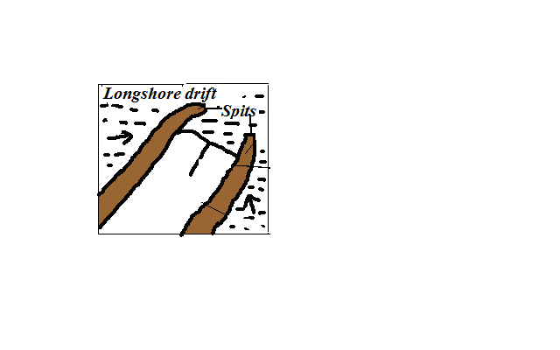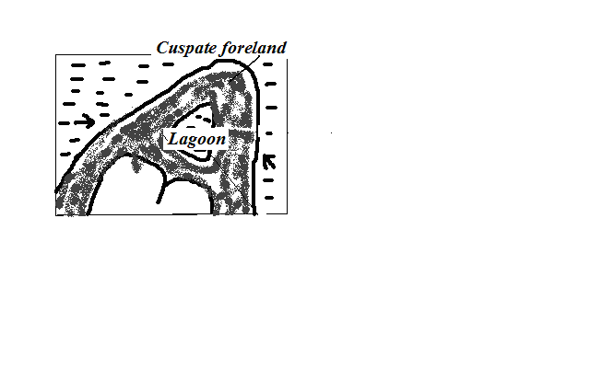

(d) Explain four significance of oceans to human activities. (8mks)

1. **Oceans provides building materials e.g. sand, coral rocks**
2. **Oceans modify the climate of the adjacent lands thus enhancing agricultural activities.**
3. **Oceans are used by water vessels thereby enhancing transport/communication.**
4. **Oceans provide sites for recreational activities thus promoting tourism.**
5. **Oceans are habitats for aquatic life hence encouraging fishing.**
6. **Oceans contain minerals which are extracted for economic development.**
7. **Ocean waves/tides are harnessed to generate electric power for industrial/domestic use.**
8. **Oceans provide water for cooling industrial plants.**
9. **Oceans encourage education and research.**
10. **Oceans provide ideal grounds for testing military weapons.**

**Significance of Coasts and Coastal Features**

1. **Submerged coasts like fiords and rias favour the development of ports and harbours.**
2. **Sheltered waters of the fiords provide favourable breeding grounds for fish which are harvested for commercial/domestic purposes.**
3. **Coastal features like sand beaches, caves, fiords attract tourists earning a country foreign exchange.**
4. **Raised coral reefs are a source of coral limestone used in the manufacture of cement for building and construction.**
5. **Coastal features like lagoons, fiords, coral reefs, continental shelf provide suitable grounds for marine life breeding e.g. Malindi marine national park.**
6. **Mudflats support the growth of mangrove trees which provide strong building poles. Mangrove trees also provide sites for research purposes in biogeography.**
7. **Coasts form good sites for development of urban centres like New York, Tokyo, Mumbai, Sao Paulo and Rio de Jeneiro.**
8. **Depositional features like sand dunes/coral reefs inhibits water transport and development of ports. Tankers will hit coral reefs causing oil spills.**
9. **Emerged coasts have poor sandy soils unsuitable for growing of a variety of crops.**